**SMART GEYSER**

An Internship Work submitted to



**VISVESVARAYA TECHNOLOGICAL UNIVERSITY**

in partial fulfilment of the requirements

for the award of degree of

**Bachelor of Engineering**

**in**

**Electronics and Communication Engineering**

**Submitted by**

**SUSHMA.S**

**1KG16EC103**

**For**

**Internship Carried out**

**At**

**ACCESS6 TECHNOLOGIES**

**#482, 2nd floor, 3rd Stage, Above Cafe Coffee Day,**

**BEML Layout, RR Nagar, Bengaluru,**

**Karnataka 560098**

|  |  |
| --- | --- |
| **Internal Guide**  **Shanthala.G.M**  **Associate Professor, Dept. of ECE**  **K S School of Engineering and Management** | **External Guide**  **<Name of the Guide>**  **<Designation>**  **<Company Name>** |



Department of Electronics and Communication Engineering

K.S. School of Engineering and Management

No. 15, Mallasandra, off Kanakapura Road, Bengaluru-560109

**2019-20**



**K.S. SCHOOL OF ENGINEERING AND MANAGEMENT**

**DEPARTMENT OF ELECTRONICS AND COMMUNICATION ENGINEERING**

**CERTIFICATE**

This is to certify that the internship work **SMART GEYSER** is a bonafide work carried out by **SUSHMA.S 1KG16EC103** in partial fulfilment for the award of **Bachelor of Engineering** in **Electronics and Communication Engineering**of **Visvesvaraya Technological University, Belagavi,** during the year 2019-20. It is certified that all the suggestions indicated during internal assessment have been incorporated in the report and this report satisfies the academic requirement with respect to **Internship (15EC84)** prescribed for the degree.

|  |  |  |  |
| --- | --- | --- | --- |
| **Internal Guide** | **External Guide** | **Head of the Department** | **Principal** |
|  |  |  |  |
| **Shanthala.G.M**  Associate Professor  Dept. of ECE | **<Name>**  <Designation>  <Company Name> | **Dr. Girish V Attimarad**  Professor& Head,  Dept. of ECE,  KSSEM, Bangalore. | **Dr. K. Rama Narasimha**  KSSEM, Bangalore. |

**Examiners**

_____________________________ ____________________________

Name and Signature of Examiner-1 Name and Signature of Examiner-2





**K.S. SCHOOL OF ENGINEERING AND MANAGEMENT**

**DEPARTMENT OF ELECTRONICS AND COMMUNICATION ENGINEERING**

**DECLARATION**

I **SUSHMA.S 1KG16EC103,** the students of **BE VII Semester (Electronics and Communication Engineering)** declare that the internship report entitled **“SMART GEYSER”** is carried out by me at **ACCESS6 Technologies** as a partial fulfilment of academic requirement of degree under **Visvesvaraya Technological University.** The content in the report are original and are free from plagiarism and other academic dishonesty and are not submitted to any other University either partially or wholly for the award of any other degree.

**SUSHMA.S**

**1KG16EC103**

Date:

Place: Bengaluru

# ACKNOWLEDGEMENT

The successful completion of this internship was made possible with the help of guidance received from our faculty members. We would like to avail this opportunity to express our sincere thanks and gratitude to all of them.

We express our profound gratitude to <**External Guide Name>, <Designation>, <Company Name>, <Company Address>, Bengaluru,** for his/her keen interest and encouragement in the internship whose guidance made the internship into reality.

We are grateful to our management for providing the necessary infrastructure and an ambience environment to work. We express our profound gratitude to **Dr. K Rama Narasimha, Principal and Dr. Girish V Attimarad, Professor & Head of the Department, KSSEM, Bengaluru** for providing the necessary infrastructure and an ambience environment to work.

We are grateful to my guide **Shanthala.G.M, Associate Professor, Department of Electronics and Communication Engineering, KSSEM ,Bengaluru** for her valuable suggestions and advice throughout our work period.

We would also like to thank all the staff members of Department of Computer Science and Engineering for their support and encouragement. Finally, we would like to thank all of our friends without whose help and encouragement this project would have been impossible.

Definitely most, we want to thank our family. Words cannot express our thanks to our family members for all their love and encouragement.

**SUSHMA.S**

**1KG16EC103**

# ABSTRACT

Since water heating is a rudimentary task of our day-to-day life, it has been turned into efﬁcacious technology through water geyser system. Water geyser is used for thermodynamically heating water above its normal temperature. Its usage incorporates in bathing, washing, cooking & many where. So to corroborate the public demand, the key challenge is to make the system more cheap but efﬁcient, handy but less erroneous. To hold its performance as well as cost, we need to design such a system that will provide us with exactly how we expect it to be. As we can see today there are several geysers working based on electricity and combustible gas. But these are not so efficient as they consume more time to heat the water. So our project “SMART GEYSER” deals with the idea of water heating with less time and improved safety by using induction technology.

The system is smart since user can give inputs he requires i.e. the amount of water in liters and the required level of temperature through a remote. Then the system processes the given inputs and outputs the result as desired by user. The controller used here for processing is arduino UNO. The system uses a dc valve and a flow meter to control the water flow which are controlled by the ardiuno. LCD display is provided which acts as the interface between machine and user. Also it uses a stainless steel storage unit along with pipeline network which is linked to a magnetic field generated by an induction coil. Thus smart induction geyser is a complete embedded system with better performance and less time consuming when compared to other existing geysers.

# TABLE OF CONTENTS

ACKNOWLEDGEMENT i

ABSTRACT ii

TABLE OF CONTENTS iii

LIST OF FIGURE iv

NOMENCLATURE v

Chapter 1 11

COMPANY PROFILE 11

1.1 Introduction 11

1.2 Technologies we deliver 11

1.3 Consulting 12

1.4 Training 12

Chapter 2 13

DESIGNING OF SMART GEYSER 13

2.1 Introduction 13

Chapter 3 14

WORK ASSIGNED 14

3.1 Objectives 14

Chapter 4 15

WORK COMPLETED 15

4.1 Methodology 15

4.2 Execution 15

4.2.1 Components 15

4.2.2 Architecture 22

4.2.3 Flowchart of Smart Geyser 23

4.2.4 Multisim Software 24

4.3 Technical Outcome 32

Chapter 5 33

CONCLUSION 33

# LIST OF FIGURE

|  |
| --- |
| Figure 1. 1 Access6 Technologies 10  Figure 4. 1 Arduino Uno 15  Figure 4. 2 PIR sensor 15  Figure 4. 3 Electret Mic Breakout 17  Figure 4. 4 ESP8266EX 17  Figure 4. 5 ESP 8266 WIFI MODULE 18  Figure 4. 6 Racold thermostat 18  Figure 4. 7 The IR transmitter 19  Figure 4. 8 Fingerprint scanner 20  Figure 4. 9 Gesture Sensor 20  Figure 4. 10 Architecture of smart geyser 21  Figure 4. 11 Flow chart of Smart Geyser 22  Figure 4. 12 Multisim Window 23  Figure 4. 13 Standard Toolbar 23  Figure 4. 14 Component Toolbar 24  Figure 4. 15 view toolbar 25  Figure 4. 16 Graphic Annotation Toolbar 25  Figure 4. 17 Workspace 26  Figure 4. 18 Full Adder Simulation circuit 29  Figure 4. 19 Full Adder Circuit in Multisim 29  Figure 4. 20 PCB Design of Full Adder 30  Figure 4. 21 Interfacing of Arduino and LED 31  Figure 4. 22 Interfacing of Sensor with Arduino 31 |

# 

# NOMENCLATURE

|  |  |
| --- | --- |
| **IOS** | IPHONE OPERATING SYSTEM |
| **PHP** | PERSONAL HOME PAGE |
| **ACE** | ACCESS6 COMPUTER EDUCATION'S |
| **SMB** | SERVER MESSAGE BLOCK |
| **IT** | INFORMATION TECHNOLOGY |
| **HTD** | HEAT TRANSFER DIVISION |
| **EEPROM** | ELECTRICALLY ERASABLE PROGRAMMABLE READ-ONLY MEMORY |
| **USB** | UNIVERSAL SERIAL BUS |
| **ICSP** | IN CIRCUIT SERIAL PROGRAMMING |
| **PIR** | PASSIVE INFRARED SENSOR |
| **IR** | INFRARED (IR) SENSOR |
| **TTL** | TRANSISTOR-TRANSISTOR LOGIC, |
| **ADC** | ANALOG-TO-DIGITAL CONVERTER. |
| **WI-FI** | WIRELESS FIDELITY |
| **CAD** | COMPUTER-AIDED DESIGN |
| **PCB** | PRINTED CIRCUIT BOARD |

# Chapter 1

# COMPANY PROFILE

## Introduction

 Access6 is a Global Information and Technology Company. We have clear philosophy of “Connecting Dots…” which aims to do business and provide complete satisfaction to customers by practicing best practices by understanding the business needs and providing subsequent solution to the Clients, we aim to evolve as a complete and ‘One Stop Information and Technology Company’.

#### Figure 1. 1Access6 Technologies

**Mission**🡪To provide a dynamic, rich and satisfying platform to the Employees, Clients and its associated members.

**Vision**🡪 Our vision is to be the global innovator in the direct enablement of the Data Management, software design, development, deployment and maintenance community in adapting software engineering principles, methodologies and tools.

Access6 offers dedicated outsourced IT services to create sustainable business value for leading information technology services providers, independent software vendors and end user companies across the globe. Our service offerings include Data Management, Application development and management, packaged implementation, Independent software testing and consulting.

## Technologies we deliver

* Cloud Technologies- Amazon Web Services, IBM Blue Mix, Microsoft Azure.
* Mobile Platforms- IOS and Android.
* IT infrastructure Design and development- IBM/HP.
* Java and PHP technologies on Opensource soluions
* Oracle, MySQL, Big Data for Data Analytics Tubule, IBM Cognos Data Visualization.
* IOT – Internet of things- Arduino, OIC and Raspberry PI platform- Homw, Office, Business, Process Automation.
* Managed Services- IT infrastructure monitor and Manage-Servers, Database, Desktop, Network.
* Oil and Gas, Retail, Healthcare, Manufacturing, Education, Hospitality, Pharma Services-Large and SMB.

## Consulting

Our Consulting Services accelerate your digital transformation journey with our world-class expertise and knowledge center services from strategy to implementation. ACE– Access6 Computer Education's- Knowledge Center for Technology & Management Training is an initiative started by Access6, It aims at providing training to qualifying professionals and students on emerging technologies like Big Data, Analytics, Cloud, Mobility, Digital Marketing and many more.Once trained, we provide Certification assistance and also provide Placement assistance to qualifying students & professionals. With over decade of experience in the Industry, we understand its trend, and our courses are specially designed to ensure successful careers. At Access6, we provide e-business and enterprise solutions to India’s top corporates. We work in close association with some of the world’s top IT companies in supporting their Fortune 100 customers across the globe.We take great pride in the work we do and the talented people who work with us. We’re always looking for highly skilled, ambition driven people who value a collaborative, open environment and a flexible, professional culture..

## Training

Our training solutions are developed by subject matter experts to help organizations and individuals improve Technical, Personal competence and Skills – core enablers of sustainable business development and competitive advantage.

Categorized into:

* College toCampus
* Corporate
* Job Oriented SkillsDevelopment

# Chapter 2

# DESIGNING OF SMART GEYSER

## Introduction

Water is an integral part of our lives. Aside from being a bare necessity for survival, it is perhaps the single most important part of our daily living because we use it for domestic chores such as bathing, cooking, washing, and more.

Over time, people have discovered that hot water is more useful compared to lukewarm water, and with that, technology has offered us many options to obtain hot water.Up until very recently in human history, water was heated in kettles and pots, however, we are unable to get a continuous supply of hot water at fixed temperatures through this process. To solve this problem, water heaters were invented. They were able to provide us heated water continuously at preset temperatures at any time we want with just a touch of a button.

All water heaters have the ability to monitor water temperature in the tank. The main thing that separates smart water heaters from conventional ones, is the ability to make further use of that data. Conventional water heaters are equipped with a thermostat, which keeps the water temperature at a set level. This device simply turns the heater on, when the water is too cold and off again when the water reaches a predefined temperature.

Water heaters utilize an energy source to be able to heat water until it reaches the programmed temperature level. However, the major flaw of a water heater, either electrical or solar,  is it consumes a large amount of energy.Once hot water is released from the water heater, then more cold water comes in and is constantly being heated. Today, there is the newest addition to the many types of water heaters which is the Smart Water Heater

# Chapter 3

# WORK ASSIGNED

## Objectives

Smart water heaters are certainly very convenient devices especially for people who have busy schedules and for those who constantly forget to turn off their water heaters at home when they leave.

1. **Safety**

Smart water heaters promote safety because you can monitor them even when you’re not at home. When something is wrong with your heating system or if there’s a leakage, it will alert you and you can immediately attend to it. Unlike regular water heaters, having a smart water heater will prevent you from going home to a flooded basement or closet because you didn’t know that a valve has broken.

1. **Saves Energy**

As stated earlier, a lot of water heaters were created with the aim to lessen energy consumption. There are a number of ways that smart water heaters can save energy. One is that they allow consumers to lower its temperature when no one is home, and it is done through the use of web-based or mobile applications.Another one is that smart water heaters can adjust their own energy levels. This is based on actual usage and can also be through coordination with other sensor-based devices at home like thermostats and motion detectors

1. **User Friendly**

As this is not much time consuming it can also be operated using new technologies like Wi-Fi and Bluetooth from the place where consumer is and it is convenient to use.

# Chapter 4

# WORK COMPLETED

## Methodology

The above objectives can be achieved by using the components like :-**Methodology of Objective 1🡪**when we think about safety we will be using various sensor so that it senses in any leakage of current or any failure of internal hardware we will be getting the message through the android application which will be attached to registered mobile.

**Methodology of Objective 2🡪**when it comes to saving energy Arduino Uno plays a vital role because when the user set a desired temperature Arduino keeps sensing the temperature level and saves the energy in additional wastage. When we set a temperature, that is saved in the EEPROM and when restarted the previous temperature is loaded and it will be cut-off at that temperature.

**Methodology of Objective 3🡪**When we consider the user friendly objective instead of going manually and switching on or off the geyser here we make use of mobile device application so that in any place anywhere the user can set the temperature value.

## Execution

The following steps show the execution of the smart geyser using various components:-

### 4.2.1 Components

###### Arduino Uno

The **Arduino Uno** is a microcontroller board based on the ATmega328.The Arduino Uno has 14 digital input/output pins (of which 6 can be used as PWM outputs), 6 analog inputs, a 16 MHz crystal oscillator, a USB connection, a power jack, an ICSP header, and a reset button. It contains everything needed to support the microcontroller; simply connect it to a computer with a USB cable or power it with a AC-to-DC adapter or battery to get started.and the Features.

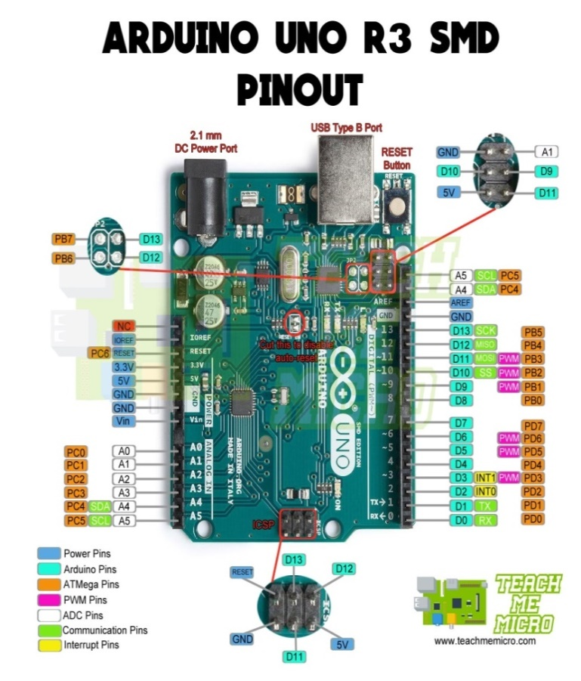

Figure 4. 1Arduino Uno

###### Pir Sensor

A passive infrared sensor (PIR sensor) is an electronic sensor that measures infrared (IR) light radiating from objects in its field of view. PIR sensors detect general movement, but do not give information on who or what moved. For that purpose, an active IR sensor is required.

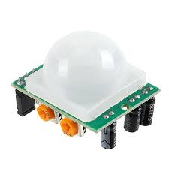

Figure 4. 2PIR sensor

**Working🡪**The PIR sensors are more complicated than the other sensors as they consists of two slots. These slots are made of a special material which is sensitive to IR. The Fresnel lens is used to see that the two slots of the PIR can see out past some distance. When the sensor is inactive, then the two slots sense the same amount of IR.The ambient amount radiates from the outdoors, walls or room,etc.

When a human body or any animal passes by, then it intercepts the first slot of the PIR sensor. This causes a positive differential change between the two bisects.When a human body leaves the sensing area,the sensor generates a negative differential change between the two bisects. The infrared sensor itself is housed in a hermetically sealed metal to improve humidity/temperature/noise/immunity. There is a window which is made of typically coated silicon material to protect the sensing element.

**Features**🡪Complete with PIR, Motion Detection.

• Dual Element Sensor with Low Noise and High Sensitivity.

• Supply Voltage – 5V.

• Delay Time Adjustable.

• Standard TTL Output.

• Pet immunity (to reduce false alarms)

• Long battery life (high-quality PIR sensors can last multiple years on one battery)

• High-count lens array

• High number of detector elements

###### Voice Recognition Module

This small breakout board couples an Electret microphone (100Hz--10kHz) with a 60x mic preamplifier to amplify the sounds of voice, claps, door knocks or any sounds loud enough to be picked up by a microcontroller’s analog-to-digital converter. Each breakout comes fully assembled and works from 2.7V up to 5.5V.The Electret Mic Breakout translates amplitude (not volume) by capturing sound waves between two conducting plates (one a vibrating diaphragm and the other fixed) in the microphone and converting them into electrical waves. These electrical signals are then amplified and picked up by your microcontroller’s ADC.

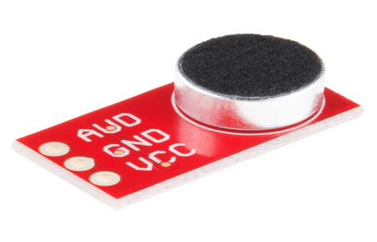

Figure 4. 3Electret Mic Breakout

###### Wi-Fi Module Esp8266

ESP8266EX delivers highly integrated Wi-Fi SoC solution to meet userscontinuous demands for efficient power usage, compact design and reliable performance in the Internet of Things industry. With the complete and self-contained Wi-Fi networking capabilities, ESP8266EX can perform either as a standalone application or as the slave to a host MCU. WhenESP8266EX hosts the application, it promptly boots up from the flash. The integrated high-speed cache helps to increase the system performance and optimize the system memory.

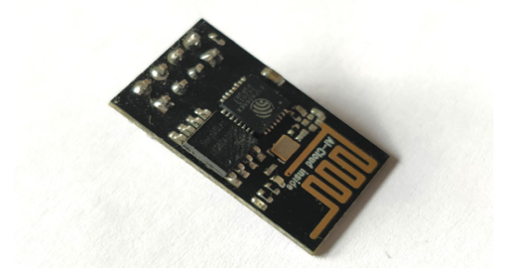

Figure 4. 4ESP8266EX

**ESP8266-01 Features🡪**

* Low cost, compact and powerful Wi-Fi Module
* Power Supply: +3.3V only
* Current Consumption: 100mA
* I/O Voltage: 3.6V (max)
* I/O source current: 12mA (max)
* Built-in low power 32-bit MCU @ 80MHz
* 512kB Flash Memory
* Can be used as Station or Access Point or both combined
* Supports Deep sleep (<10uA)

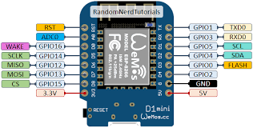

Figure 4. 5ESP 8266 WIFI MODULE

###### Thermostat

A thermostat is a component which senses the temperature of a physical system and performs actions so that the system's temperature is maintained near a desired setpoint.Thermostats are used in any device or system that heats or cools to a setpoint temperature, examples include building heating, central heating, air conditioners, HVAC systems, water heaters, as well as kitchen equipment including ovens and refrigerators and medical and scientific incubators. In scientific literature, these devices are often broadly classified as thermostatically controlled loads (TCLs). Thermostatically controlled loads comprise roughly 50% of the overall electricity .The water tank is fitted with heating elements which are controlled by thermostats. The principle on which the geyser works is simply the conversion of electrical energy into heat through the use of heating elements to raise the temperature of water through conduction of the heat to the water.

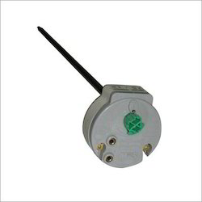

Figure 4. 6Racold thermostat

###### Buzzer

A **buzzer**is a small yet efficient component to add sound features to our project/system. It is very small and compact 2-pin structure hence can be easily used on breadboard, Perf Board and even on PCBs which makes this a widely used component in most electronic applications.There are two types are buzzers that are commonly available. The one shown here is a simple buzzer which when powered will make a Continuous Beeeeeeppp.... sound, the other type is called a readymade buzzer which will look bulkier than this and will produce a Beep. Beep. Beep.Sound due to the internal oscillating circuit present inside itThis buzzer can be used by simply powering it using a DC power supply ranging from 4V to 9V. A simple 9V battery can also be used, but it is recommended to use a regulated +5V or +6V DC supply.

###### IR Sensor

An IR transmitter, also known as IR LED, sends an infrared signal with a certain frequency compatible with an IR receiver which has the task to detect it. There are different kind of IR sensors for different type of application. The IR transmitter sends an infrared signal that, in case of a reflecting surface (e.g. white color), bounces off in some directions including that of the IR receiver that captures the signal detecting the object.When the surface is absorbent (e.g. black color) the IR signal isn’t reflected and the object cannot be detected by the sensor. This result would occur even if the object is absent.

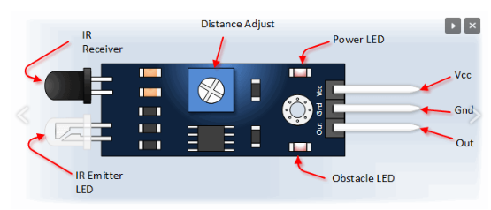

Figure 4. 7 The IR transmitter

###### Fingerprint Sensor

The GT-511C3 FPS (fingerprint scanner) is a small embedded module that consists of an optical sensor mounted on a small circuit board. The optical sensor scans a fingerprint and the microcontroller and software provides the modules functionality which automatically processes the scanned fingerprint. The interface of the FPS is very basic consisting of only four pins – power, ground, serial transmit and serial receive. The module can be used in projects for identifying users, for example allowing access through a door by scanning a finger instead of using a key.

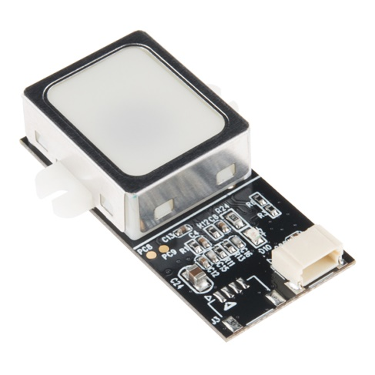

Figure 4. 8Fingerprint scanner

###### Gesture Sensor

By swiping your hand over a sensor, you can control a computer, microcontroller, robot, etc. This is the Spark Fun RGB and Gesture Sensor, a small breakout board with a built in APDS-9960 sensor that offers ambient light and colour measuring, proximity detection, and touch less gesture sensing. With this RGB and Gesture Sensor you will be able to control a computer, microcontroller, robot, and more with a simple swipe of your hand! The APDS-9960 is a serious little piece of hardware with built in UV and IR blocking filters, four separate diodes sensitive to different directions, and an I2C compatible interface.

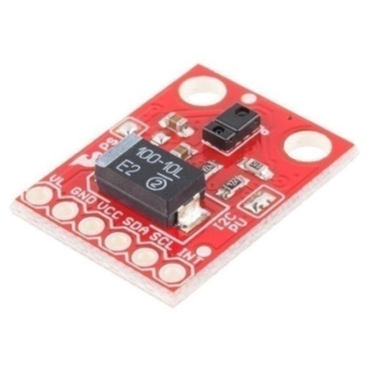

Figure 4. 9Gesture Sensor

### 4.2.2 Architecture

The system diagram shown in ﬁgure 1 shows

the relationship between the various parts of the system

The system diagram shown in ﬁgure 1 shows

the relationship between the various parts of the system

**The required temperature of each person is stored and accessed when required**

**Hot Water**

**Cold Water**

**Water of**

**Required**

**Temperature**

**Finger Print Sensor**

**And**

**Gesture Recognition**

**Using mobile**

**Voice Recognition**

**Output**

Figure 4. 10 Architecture of smart geyser

**Architecture Explanation🡪**The architecture tells us about the basic working procedure of the smart geyser, firstly we give the input to the system through either fingerprint sensor or gesture recognition sensor which senses the fingerprint of the user or it recognizes the gesture done by the user and the system recognizes the user and sets the temperature for the user which will be set initially according to their needs.In case if the users need to change their default temperature they can change through voice recognition the changed temperature will be updated until the user changes temperature again. This system can be controlled even through mobile using the app, If consumer requires any changes in temperature of water while travelling back home He/she can set the temperature using mobile app.Once the input is given then the information is given to the geyser from the memory unit about the temperature required to the user. The user have three chambers 1st hot water chamber,2nd is cold water (normal water) chamber and the 3rd chamber consists of water at required temperature this can be done with the help of thermostat i.e. the required temperature from the memory unit will be set to the thermostat then the hot water and cold water will be mixed till the required temperature is reached. Here the PIR sensor is used to switch on and off the lights of the washroom.

### 4.2.3 Flowchart of Smart Geyser

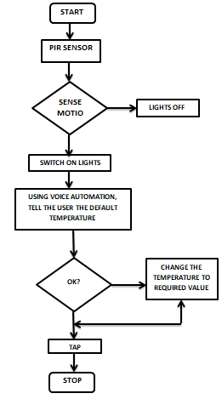

Figure 4. 11 Flow chart of Smart Geyser

**TAP**

**CHANGE THE TEMPERATURE TO REQUIRED VALUE**

**OK?**

As seen in the above figure when the user enter the room using the Pin sensor the movement is sensed and automatically the light will be switched on using the automation the predefined value will be announced using the speaker if the same temperature is ok then the same temperature water is obtained if the user wants to change the temperature it can be changed using the mobile device or through the voice and then by tapping ok the desired temperature water will be obtained.

### 4.2.4 Multisim Software

###### Introduction

Multisim is a schematic capture and simulation application of National Instruments Circuit Design Suite. It consists of tools that assists you in carrying out the major steps in the circuit design flow. Multisim is designed for schematic entry, simulation, and feeding to downstage steps, such as PCB layout.Multisim user interface consists of many elements as shown below.

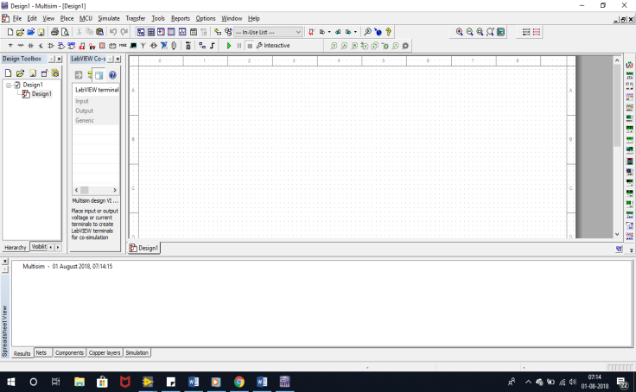

Figure 4. 12Multisim Window

###### Multisim Toolbar

The toolbars listed below are available in Multisim:-

1. **Standard Toolbar**

Standard toolbar as shown in consists of commonly used functions such as

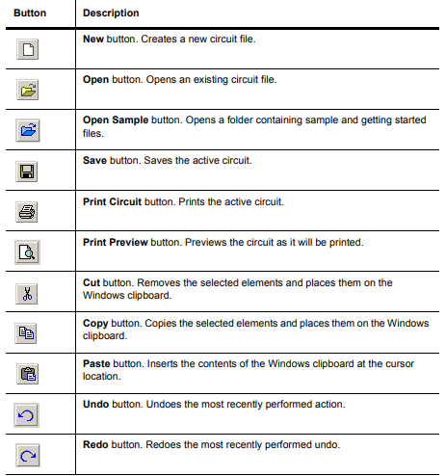

Figure 4. 13Standard Toolbar

1. **Simulation Toolbar**

**Simulation toolbar** consists of circuit operating buttons such as,

* Run: Run/resume simulation button. Starts/resumes simulation of the active circuit.
* Pause: Pause simulation button Pauses simulation.
* Stop: Stop simulation button Stops the simulation.
* Analysis and simulation: Analysis and simulation button analyses the on going simulation.
* Load simulation settings: load simulation button loads the user made settings.
* Save settings: Save button Saves the active user made settings to the circuit.
* Clear instrumental data: clears the data settings of the present loaded settings.

1. **Components Toolbar**

The buttons in the Components toolbar are described below. Each button will launch the place component browser

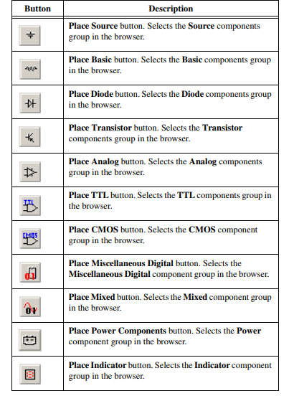

Figure 4. 14Component Toolbar

1. **View Toolbar**

The buttons in the View toolbar are described below:

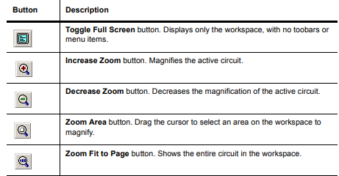

Figure 4. 15view toolbar

1. **Graphic Annotation Toolbar**

The buttons in the Graphic Annotation toolbar are described below.

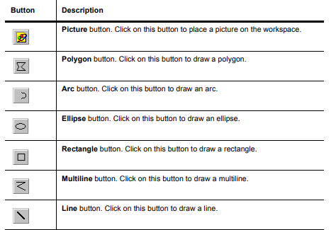

Figure 4. 16Graphic Annotation Toolbar

1. **Sheet Properties- Workspace Tab**

The options on this tab determine the appearance and behaviour of the circuit window in Multisim. Multisim comes with standard sheet sizes that you can use for capturing your circuit. You can modify any of the settings of these sizes to make your own custom sheet as shown below.

* In the Show box, enable the Show Grid, Show Page Bounds and Show Border checkboxes as desired. The results are shown in the preview area.
* In the Sheet Size box, select the desired size from the drop-down list.
* Select either Portrait or Landscape in the Orientation box.
* In the Custom Size box, you can set the Width and Height as desired.

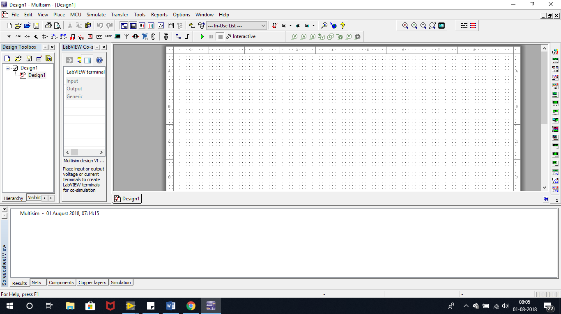

Figure 4. 17Workspace

1. **Placing Components**

The component browser is used to select parts from the component databases and place them on a circuit. Parts are organized by database, group, and family (for example, Master Database, Digital Group, TTL Family). Filters are provided as appropriate to narrow lists based on value range and tolerance where applicable. Type-ahead allows you to type a few characters to jump to the component you are looking for. Search capabilities allow you to find parts using generalized wildcard searches throughout all the databases.

The procedure used to place resistors, inductors or capacitors is quite similar to the procedure used to place other types of components. However, there are some differences. When placing any of these components, you can choose any combination of: the component’s value (for example, resistance); type (for example, carbon film); tolerance; footprint and manufacturer.

1. **Steps to build a circuit**

* Right-click in the workspace and select Place Component from the pop-up that appears.
* Click on the desired component family in the Family list, for example Resistor.
* Type the value of the component that you want to place in the field at the top of the Component list. The value does not need to appear in the list to be placed on the schematic.
* Optionally, enable the Save unique component on placement checkbox. When this is enabled, any component with a unique combination of the values in the various fields of the Select a Component dialog box will be saved to the Master Database.
* Select the desired Component Type. If you are placing a part for simulation only, select. If you do not see the desired type in the list, one can type it manually as shown Select the desired Tolerance. If you do not see the desired tolerance in the list, you can type it manually. This list does not appear for potentiometers, variable inductors, or variable capacitors.
* To confirm that this is the component one wants to place, click OK. The browser closes and the cursor on the circuit window changes to a ghost image of the component wished to be placed. This indicates that the component is ready to be placed.
* Move your cursor to the location where you want the component placed. The workspace automatically scrolls if you move your cursor to its edges.
* Click on the circuit window where you want the component placed.

1. **Replacing a Placed Component**

You can easily replace a placed component by using the Replace button in the component’s properties dialog box. The most common use for this feature is when you wish to start a circuit with virtual components, and then replace them with the nearest real components.

To replace a placed component:

* Double-click on the component you want to replace. The component’s properties dialog box appears.
* Click Replace. The Select a Component browser appears.
* Select a new component and click OK. The new component appears on the circuit window in the place of the previous one.

1. **Wiring Components**

A basic wire can be created by clicking on any one of a part's symbol pins. This creates a wire that can then be routed to either another symbol pin, or to another wire. If routed to a wire, when placed a junction is automatically created to differentiate between two wires crossing and two wires connected. Wires can also be started by double-clicking anywhere on the circuit.For Rotating/Flipping Placed Components You can rotate or flip a placed component by either using the pop-up menu or selecting the component and using commands from the Edit menu.

1. **Adding a Comment**

It allows background information to be attached to a design. You can “pin” a comment to the workspace, or directly to a component. When a component with an attached comment is moved, the comment also moves.

To pin a comment to a component or the workspace:

* Select Place/Comment.
* Move the cursor to the desired location and click to place the comment.

**To enter text in the placed comment**

* Double-click on the placed comment. The Comment Properties dialog box appears. The layer on which the comment will appear displays in the Drawing Layer list.
* Type the desired text in the field at the bottom of the dialog. If you wish to show the note’s contents, enable the Show popup window checkbox.
* Optionally, set the Background and Text colors in the Color box.
* In the Size box, enter the Width and Height, or enable Auto-Resize to have the info box automatically resize to show all content.
* Optionally, click on the Font tab to change the comment’s font.

###### Designing of Half Adder using Multisim Software

1. **Simulation circuit**

###### C:\Users\Win8\Downloads\sushma\internship\full-adder-sim-ckt-1-768x446.png

Figure 4. 18Full Adder Simulation circuit

1. **PCB Layout circuit**

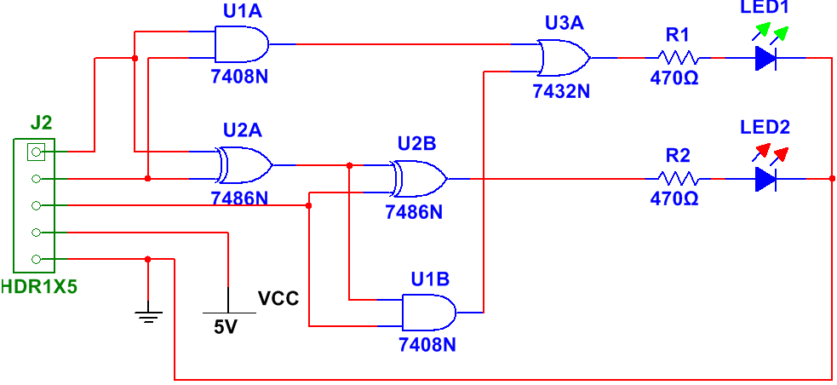

Figure 4. 19Full Adder Circuit in Multisim

1. **Procedure**

* Open MULTISIM Software, Click=> File => New => Design.
* Click File => save as in Desk Top and rename the Design1 to your circuit name then save.
* Go to Component tool bar and select PLACE BASIC icon components like resistor, LED, Switch then click PLACE TTL icon select IC 7486, 7408 and connect as per given circuit diagram and save it.
* Test the circuit with simulation RUN button.
* Remove Power source with replacement of connector.
* Change Properties of the all component into PCB Mode.
* Set the Track width = 30 mils, trace to trace and trace to pad = 10 mils,
* Go to Transfer icon => Transfer to Ultiboard 12.0 then save the file and got Import netlist and click ok.
* Go to OPTIONS icon Select PCB Properties icon and select copper layers Click properties untick routing click ok for single side PCB.
* Select all components into Board Outline and make small pcb size with the help of board Outline.
* Click Auto route icon then click auto router to make PCB Layout.
* Finally print the PCB Layout with help of printer.

1. **Output**

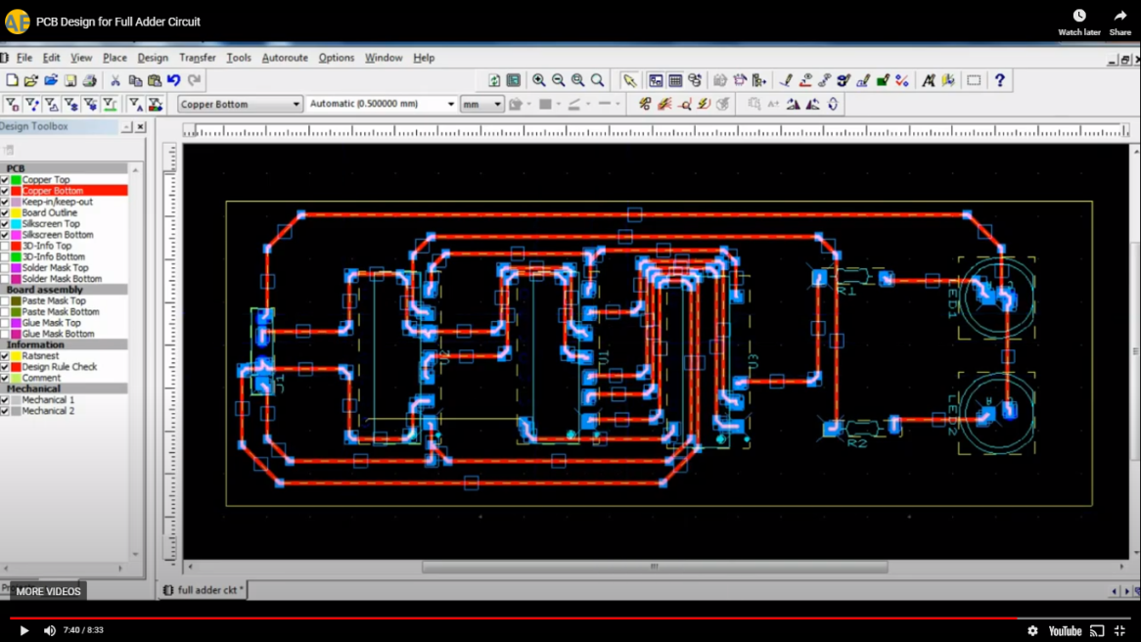

Figure 4. 20 PCB Design of Full Adder

1. **Result**

Thus the design of a single sided PCB Layout for Half Adder using Logic gates with Multisim software CAD tool was done.

## Technical Outcome

## 

Figure 4. 21 Interfacing of Arduino and LED

## 

Figure 4.22 Interfacing of Sensor with Arduino

* This project gives us an over view of smart geyser with latest technologies incorporated within.
* Where it is capable of reading the temperature from its database just by taking the input as gesture and finger print.
* It gives out hot water without wasting much amount of time and energy.

# Chapter 5

# CONCLUSION

Geyser is a water heating system mainly used in home appliances with a hot spring of boiling water. It can also be used instead of water heater, for household purposes .It works with continuous ﬂow of water. Geysers heat and retain a quantity of water inside an insulated cylinder to use at any time. They provide hot water by delivering the whole stored quantity immediately when it’s needed, and give services to multiple outlets at the same time.

To implement a new real time project called ‘smart geyser’, we have designed a flow chart and architecture of a system. which tells us about working and overall outcome. This incorporates different types of sensors, and wireless technologies like Wi-Fi, Bluetooth network with custom application software, fixtures and enclosures to construct the complete test system.

Further work that could be done on the intelligent water

heater module could include the following. Wi-Fi access

to the unit could be provided using a USB dongle instead

of using a router. This will make the unit more cost

effective and reduce the footprint of the unit. Additionally,

data logging could be implemented in order to provide the

user with monthly or even yearly totals for power usag

The work in the paper presented the design of a smart water

geyser system. The goal of implementing our smart geyser

system is to optimize the use of electricity, hence energy

consumption and calculate the heating time for each user. So,

it is providing a low cost alternative to existing solutions. But,

one of the major drawbacks include not optimizing the water

usage. Implementing a design that can reduce the water usage

can have a huge impact and make the system more desirable

to customers.